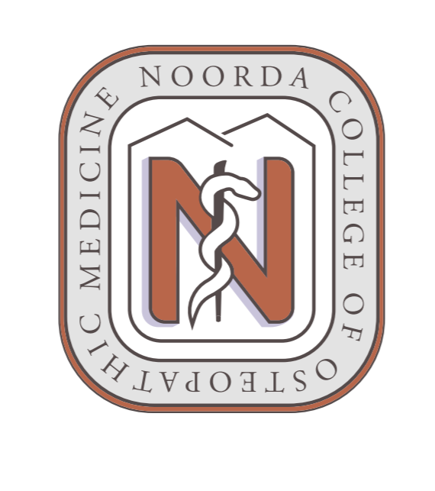Noorda COM Faculty Council

September 25, 2020
Faculty Council
- Minutes
  - Bylaws approval
  - Officers
    - Executive Committee
      - 2 each from Biomedical and Clinical Sciences
      - 1 at large
- Standing Committee Reports
- Presidents Council
    - Facilities Update
    - Safety and Security
- Dean’s Council
- Media and Information Technology
- Workforce Model
- Curriculum Council
- Assessment
- Research
- IRB
- Biosafety and Chemical Hygiene
- ACUC
- Professional Development
- HR – Safe Colleges
- Interviews
- IPE
- SDL
- Wellness
- Grievance
- PACC
- SPC
- Appeals

New Business

Adjournment

